**FITTING REPORT**

The JV curves were fitted using Landauer formula for the 6 junctions of OPEn and OPEnC where n=1,2,3.

The difference between OPEn and OPEnC is the carbon(C). The addition of carbon transforms OPEn to OPEnC and results in weak coupling between the molecule and the electrode. The models parameters , , ,, eta were calculated from the curve fitting. Fig1 shows the curve fitting for JV and plots of the model parameters. Table1 shows the values of these parameters for all the junctions investigated. is an indicator of the amount of current in the junction and we can see that decreases in the order OPE1🡪OPE1C🡪OPE2🡪OPE2C🡪OPE3C🡪OPE3. The current decreases as the junction increases in length. The part that does not follow this trend is OPE3 and OPE3C and that is because too much length in OPE3C causes the HOMO level to get into conductance window with low bias. Another observation from the fitting shows that, the eta parameter which determines the asymmetry increases as the length of the junction increased in the order OPE1🡪OPE1C🡪OPE2🡪OPE2C🡪OPE3🡪OPE3C. This happened because the ferrocene unit get positioned close to one of the electrodes and far away from the other electrode as the length of the junction increases. The parameters and remained constant.

Table1

|  |  |  |  |  |  |  |  |
| --- | --- | --- | --- | --- | --- | --- | --- |
| Junction/par | /eV |  |  | /eV |  | eta/eV |  |
| OPE1 | 5.980e-04 | 1.800e-02 | 1.08e-05 | 0.018598 | 0.700 | 0.490 | 0.150 |
| OPE1C | 2.600e-04 | 8.250e-03 | 2.150e-06 | 8.510e-03 | 0.700 | 0.500 | 0.150 |
| OPE2 | 3.866e-03 | 8.968e-05 | 3.460e-07 | 3.956e-03 | 0.700 | 0.570 | 0.150 |
| OPE2C | 2.492e-03 | 7.269e-05 | 1.810e-07 | 2.564e-03 | 0.700 | 0.600 | 0.150 |
| OPE3 | 1.626e-03 | 1.243e-05 | 2.020e-08 | 1.638e-03 | 0.700 | 0.620 | 0.150 |
| OPE3C | 1.769e-03 | 4.893e-05 | 8.660e-08 | 1.818e-03 | 0.700 | 0.630 | 0.150 |

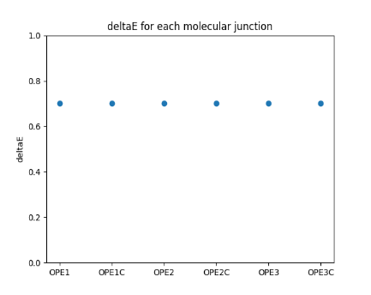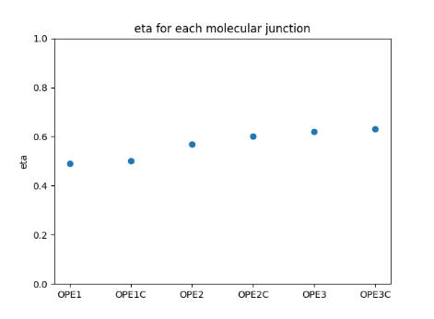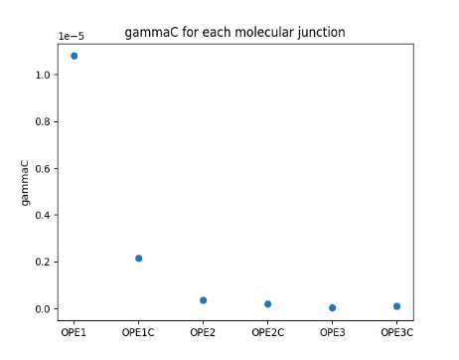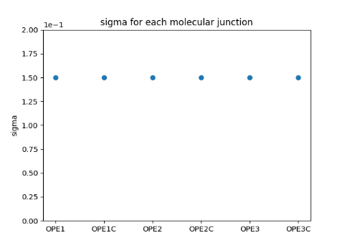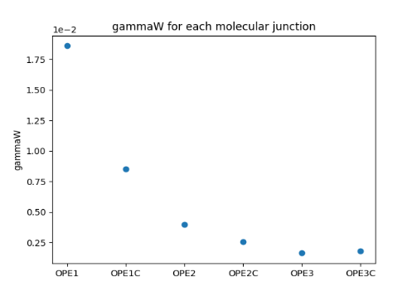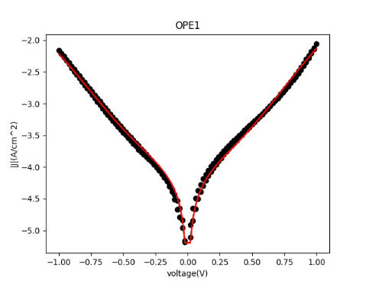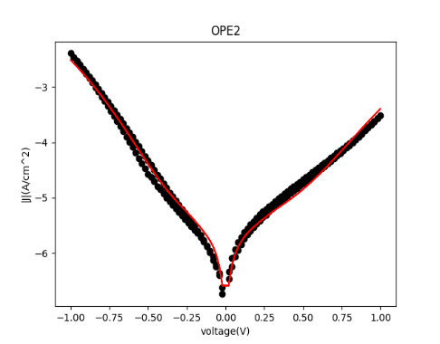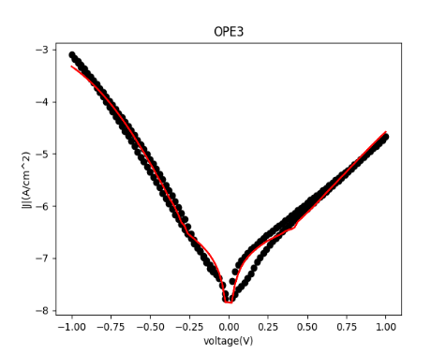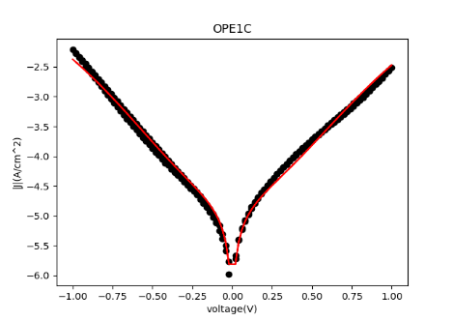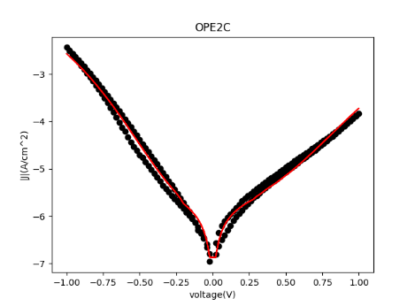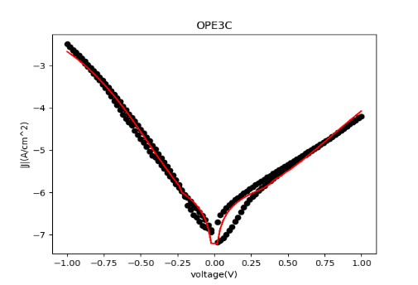

Fig1: JV curve fitting and plots of model parameters

Further investigation was made by making a temperature dependent transport measurement where temperature was varied multiple times across each junction. Again, fitting these junctions to Landauer formula revealed that, changing temperature does not affect the junction parameters for each junction.

In other words, a parameter in a particular junction does not change upon varying the temperature across the junction. A comparison made between all the junctions show that, the longer a junction is the more asymmetric it becomes looking at the eta values returned from the fitting. This was the same observation made earlier for junctions that did not depend on temperature. Table2 provides the values for model parameters across all the junctions. Fig2 shows the fitting curves and plots of model parameters.

Table2

|  |  |  |  |  |  |  |  |
| --- | --- | --- | --- | --- | --- | --- | --- |
| Junction/par | /eV | /eV | /eV | /eV | /eV | eta/eV | /eV |
| OPE1 | 1.800e-02 | 1.900e-02 | 3.420e-04 | 0.037 | 0.560 | 0.485 | 0.213 |
| OPE1C | 7.860e-02 | 7.860e-02 | 6.178e-03 | 0.1572 | 0.663 | 0.455 | 0.140 |
| OPE2 | 1.300e-02 | 1.310e-02 | 1.703e-04 | 0.0261 | 0.642 | 0.550 | 0.088 |
| OPE2C | 3.000e-02 | 2.960e-02 | 8.880e-04 | 0.0596 | 0.609 | 0.560 | 0.100 |
| OPE3 | 1.350e-02 | 1.400e-02 | 1.890e-04 | 0.0275 | 0.669 | 0.960 | 0.150 |
| OPE3C | 2.500e-02 | 4.090e-02 | 1.022e-03 | 0.0659 | 0.980 | 0.980 | 0.100 |

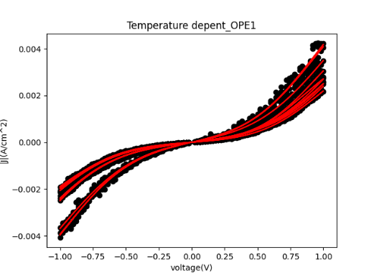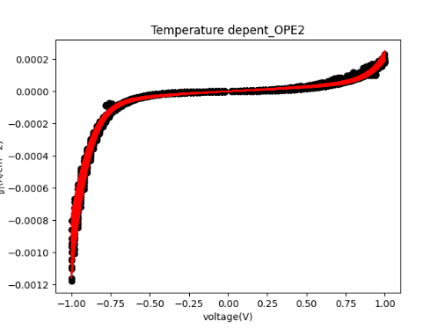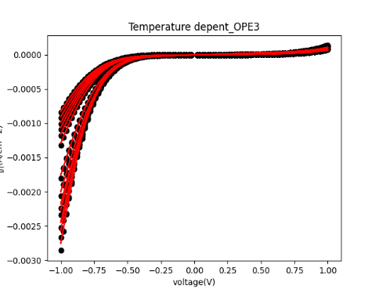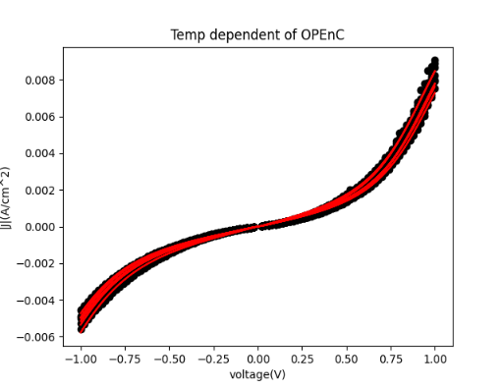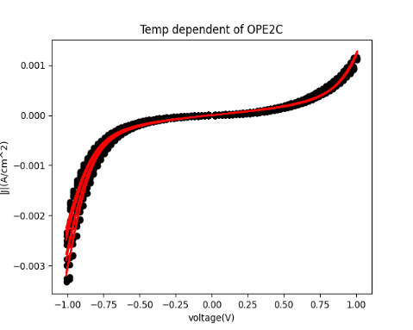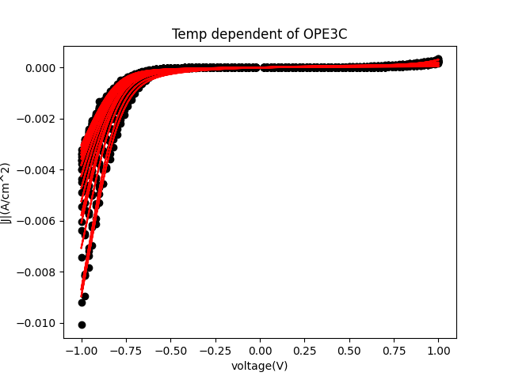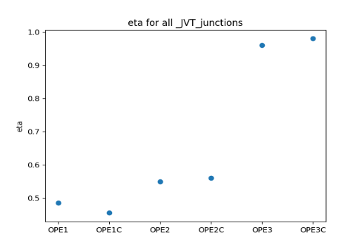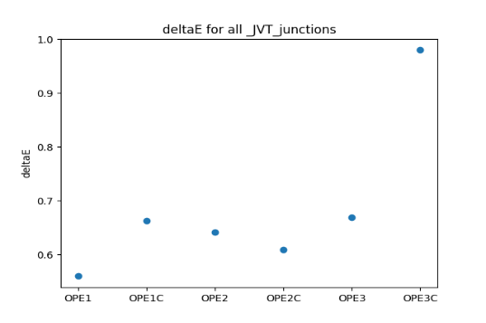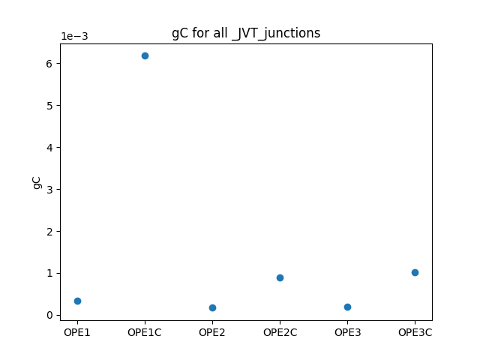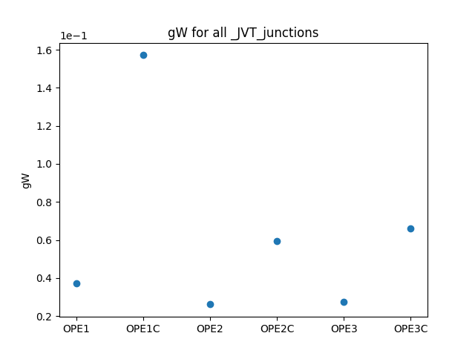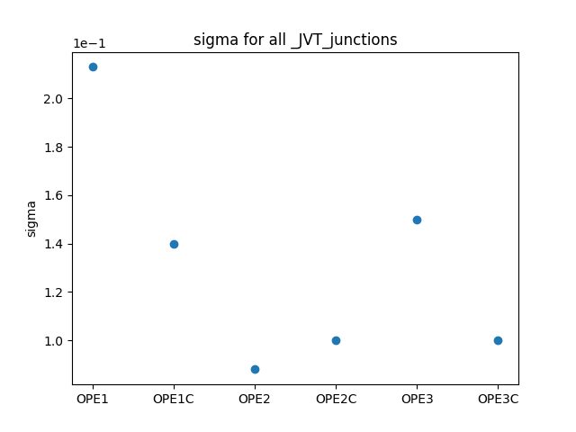

Fig2: JVT curve fitting with plots of model parameters

The corresponding activation energy derived from the temperature dependent measurement reveals important observation which is explained below:

For the two molecules OPE and OPEnC, the only difference is the carbon as already mentioned.

n is a parameter varying the length of the molecule. If the activation energy for OPE1,OPE2,OPE3,OPE1C,OPE2C and OPE3C is investigated between the voltage ranges of -1V to -0.2V and 0.2V to 1.2V, there exist 12 different junctions. The introduction of C changes the coupling between OPEn and the electrodes. The activation energy was fitted to the Nitzan’s model based on Marcus theory with the model parameters E, cap, W, A. The cap is the capacitive coupling, W is the width of the junction, A is the center/position of the junction and determines the position of the activation energy peak. The fitting results revealed that, all the OPEnC junctions had the same capacitive coupling and all OPEn had the same capacitive coupling. The capacitive capacitive coupling for OPEnC junctions was far higher than OPEn junctions. This coupling difference is as a results of intramolecular gating effect that occurs upon adding carbon.

The parameter A increased in the following fashion:

{OPE3,OPE3C}🡪{OPE2,OPE2C}🡪{OPE1,OPE1C}.If the length of the junction is increased with carbon, a peak in the activation energy is seen. On the other hand, increasing the length of the junction without carbon reveals nothing about the junction. To be more specific, in the negative voltage range a peak was seen in OPE3C and OPE2C. The parameters E, W remained the same for all junction. The peaks seen in OPE3C and OPE2C were shifting and this shift in peak is believed to be caused by the position parameter A. The capacitive coupling comes from intramolecular gating effect and this coupling is what allows the peak to exist. Without proper intramolecular gating or capacitive coupling, this is no peak.

The peaks in OPEnC in the voltage range -1.0 to -0.2 were shifting and that was caused by A. When A is small enough, the peak is shifted to our view as seen in OPE3C. When A increases, the peak gets shifted away off our view. This is obvious as the peak is OPE1C is not seen at all and OPE1C has a higher value for A. Table3 provides the vales for model parameters and the fitting is shown in fig3.

**Table3**

|  |  |  |  |  |  |
| --- | --- | --- | --- | --- | --- |
| **Junction/par** | **E/eV** |  | **Cap/F** | **W/eV** | **A/eV** |
| **1N** | **1.096e-01** | **1.56e-01** | **3.56e-21** | **6.85e-01** | **1.00** |
| **2N** | **1.096e-01** | **1.56e-01** | **3.56e-21** | **6.85e-01** | **0.800** |
| **3N** | **1.096e-01** | **1.56e-01** | **3.56e-21** | **6.85e-01** | **0.650** |
| **1P** | **1.096e-01** | **1.56e-01** | **3.56e-21** | **6.85e-01** | **1.000** |
| **2P** | **1.096e-01** | **1.56e-01** | **3.56e-21** | **6.85e-01** | **0.800** |
| **3P** | **1.096e-01** | **1.56e-01** | **3.56e-21** | **6.85e-01** | **0.650** |
| **1CN** | **1.096e-01** | **1.56e-01** | **1.60e-19** | **6.85e-01** | **1.000** |
| **2CN** | **1.096e-01** | **1.56e-01** | **1.60e-19** | **6.85e-01** | **0.800** |
| **3CN** | **1.096e-01** | **1.56e-01** | **1.60e-19** | **6.85e-01** | **0.650** |
| **1CP** | **1.096e-01** | **1.56e-01** | **1.60e-19** | **6.85e-01** | **1.000** |
| **2CP** | **1.096e-01** | **1.56e-01** | **1.60e-19** | **6.85e-01** | **0.800** |
| **3CP** | **1.096e-01** | **1.56e-01** | **1.60e-19** | **6.85e-01** | **0.650** |

**Note:**

**1N=OPE1 in the negative voltage range 1CN=OPE1C in the negative voltage range**

**1N=OPE2 in the negative voltage range 2CN=OPE2C in the negative voltage range**

**1N=OPE3 in the negative voltage range 3CN=OPE3C in the negative voltage range**

**1P=OPE1 in the positive voltage range 1CP=OPE1C in the positive voltage range**

**2P=OPE2 in the positive voltage range 2CP=OPE2C in the positive voltage range**

**3P=OPE3 in the positive voltage range 3CP=OPE3C in the positive voltage range**

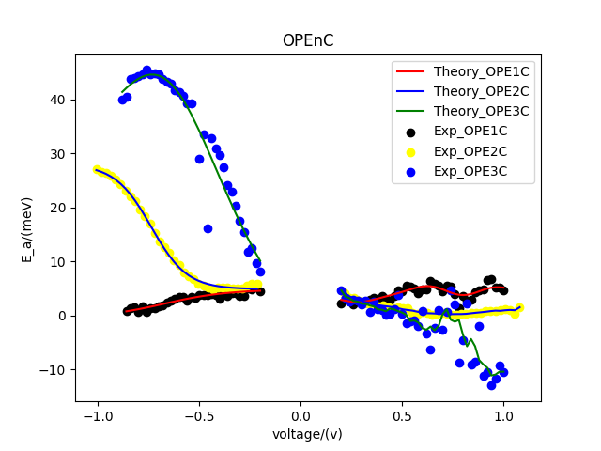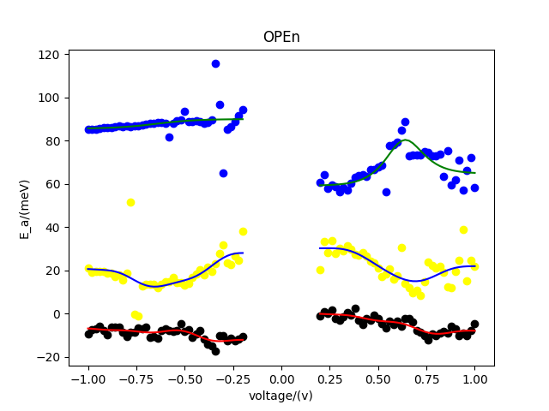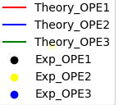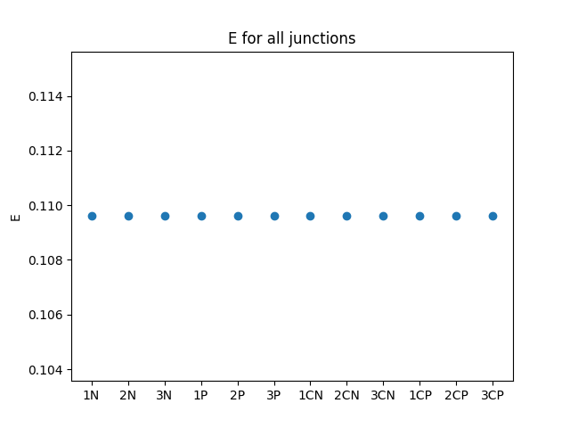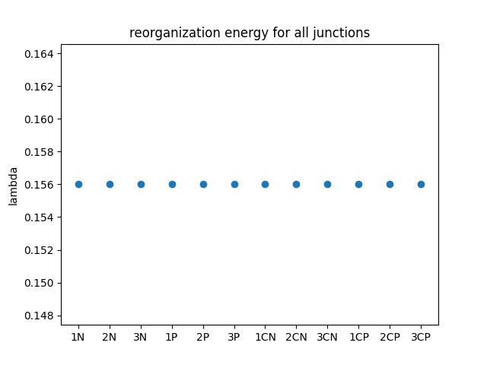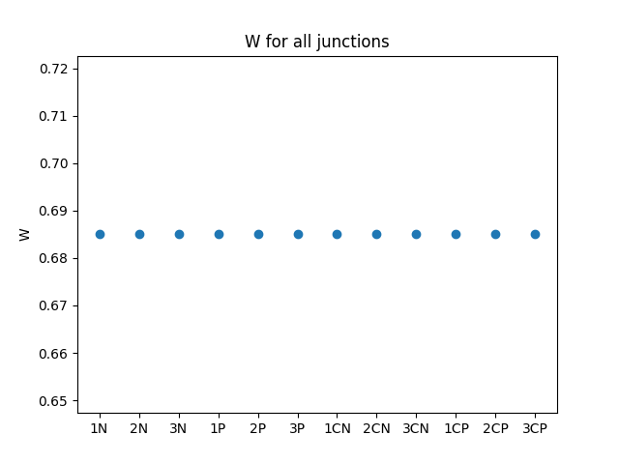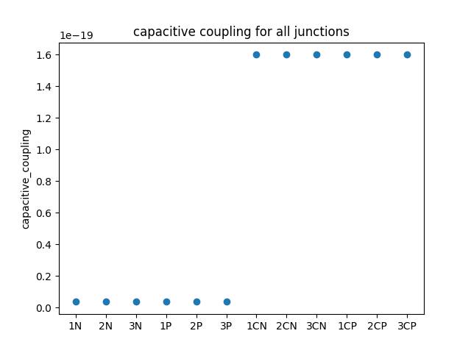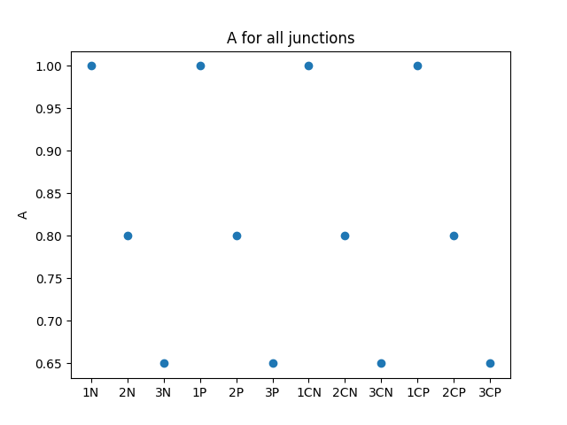

**Fig3: Activation energy curve fitting with plots of parameters**

In conclusion, what the fitting report has revealed is that, in the negative voltage range of -1.0v to -0.2v, the junctions OPE2C and OPE3C gets into the inverted Marcus regime with the position of the peak being controlled by the parameter A.